Screenshot1: Home Page

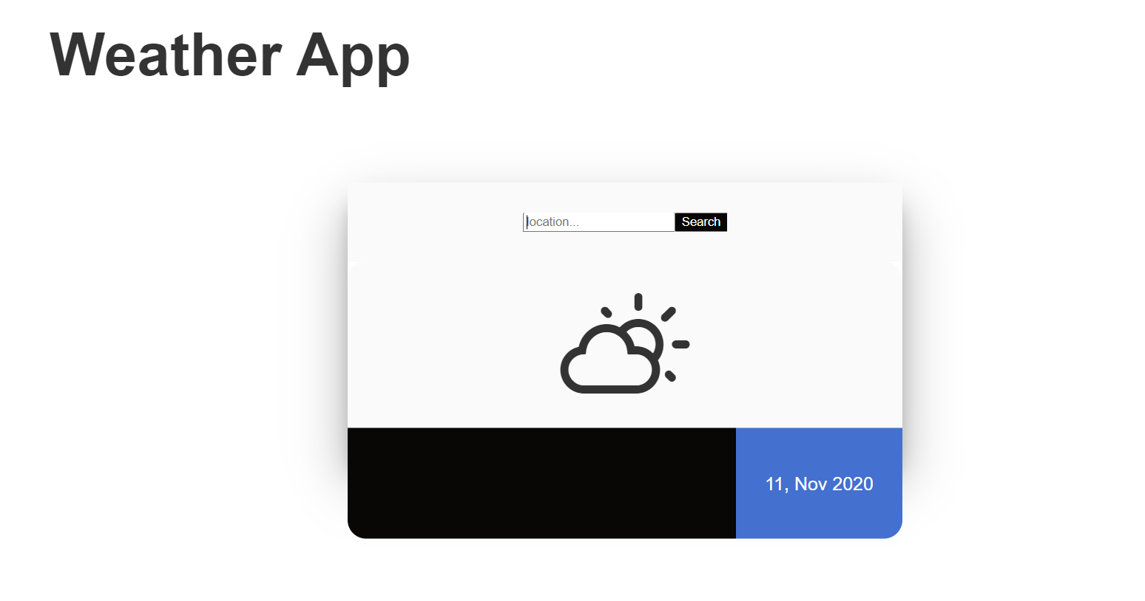

Screenshot 2: Location – Dallas,

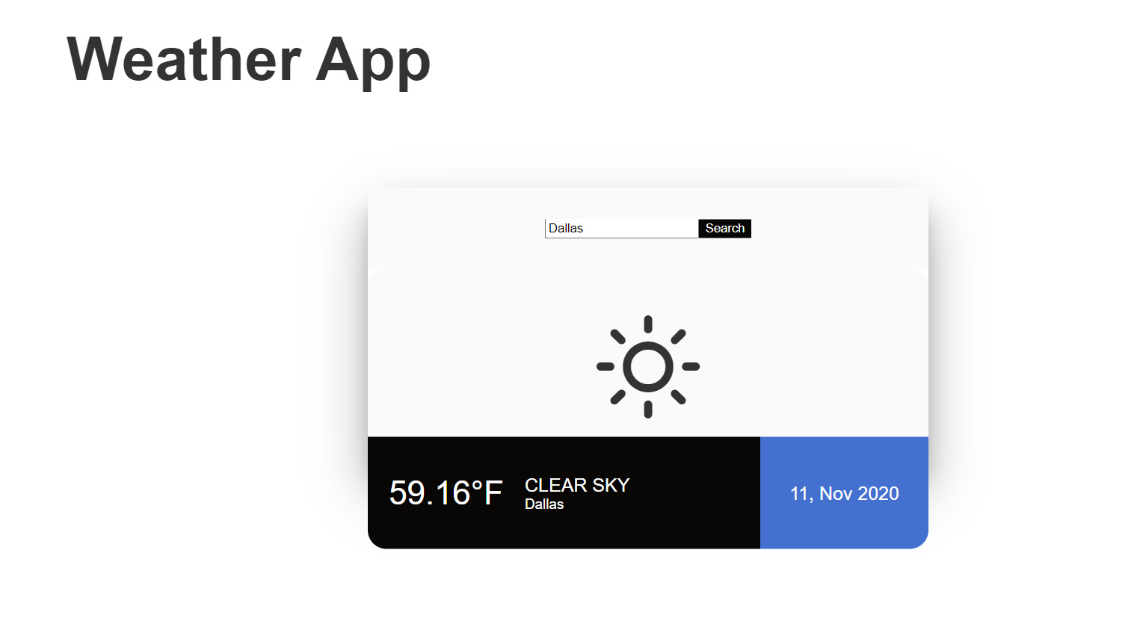

Screenshot 3: Location – Ohio

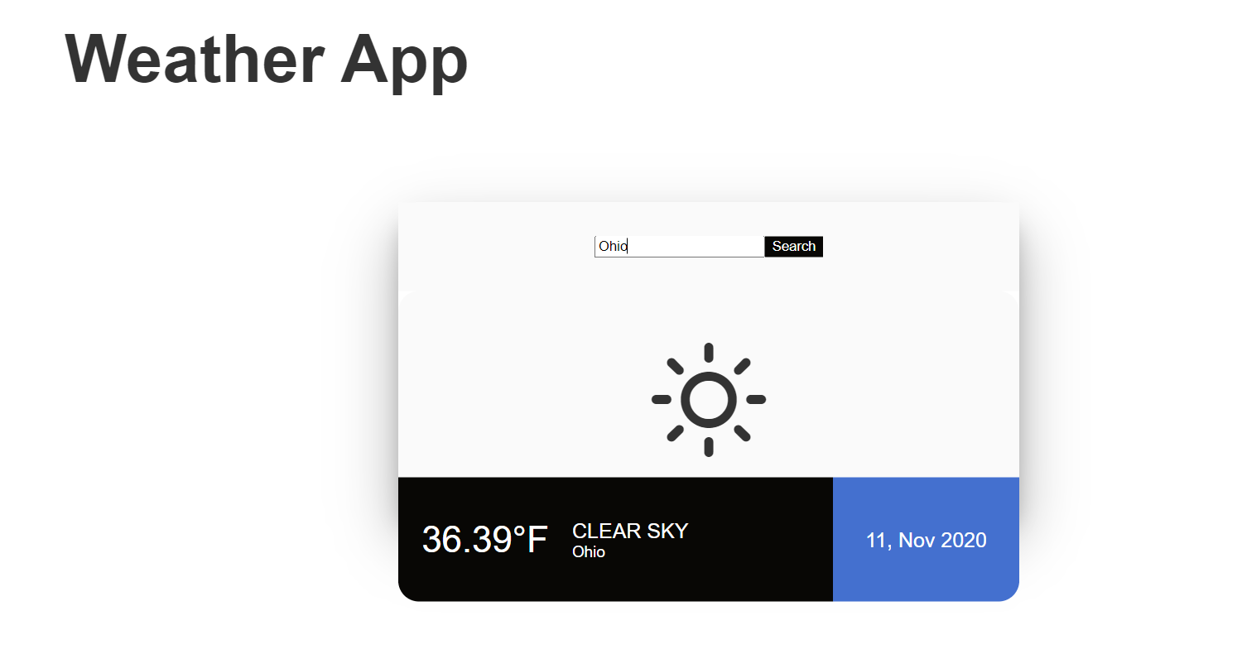

Screenshot 4: Location – Bangalore

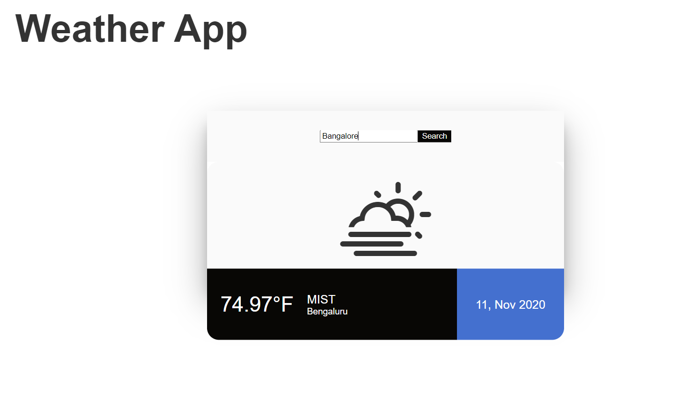

Screenshot 5: Location- Houston

